LESKERPIT Morgan 82223600

Cognitive robotics

Intermediate assignment report

Contents

Study of a discrete dynamic system 2

First examples of the Series 2

The Feigenbaum diagram 3

Study of a continuous dynamic system 5

Introduction of the system 5

Convergence over time 6

Sensitivity to the initial conditions 6

Fixed points 7

# Study of a discrete dynamic system

## First examples of the Series

For this study I decided to study the logistic map. This is a series written as follows:

$$u_{n+1}=ru_{n}(1- u_{n})$$

Where $u_{n}$ is a number between zero and one. Usually, the values of $r$ are taken between the interval [0,4] so that $u_{n}$ remains bounded on [0,1].

As we saw in class, this function is great to show how chaotic behavior can be found using very simple equations. The following graph shows how the parameter a can create those specific behaviors depending on its value.

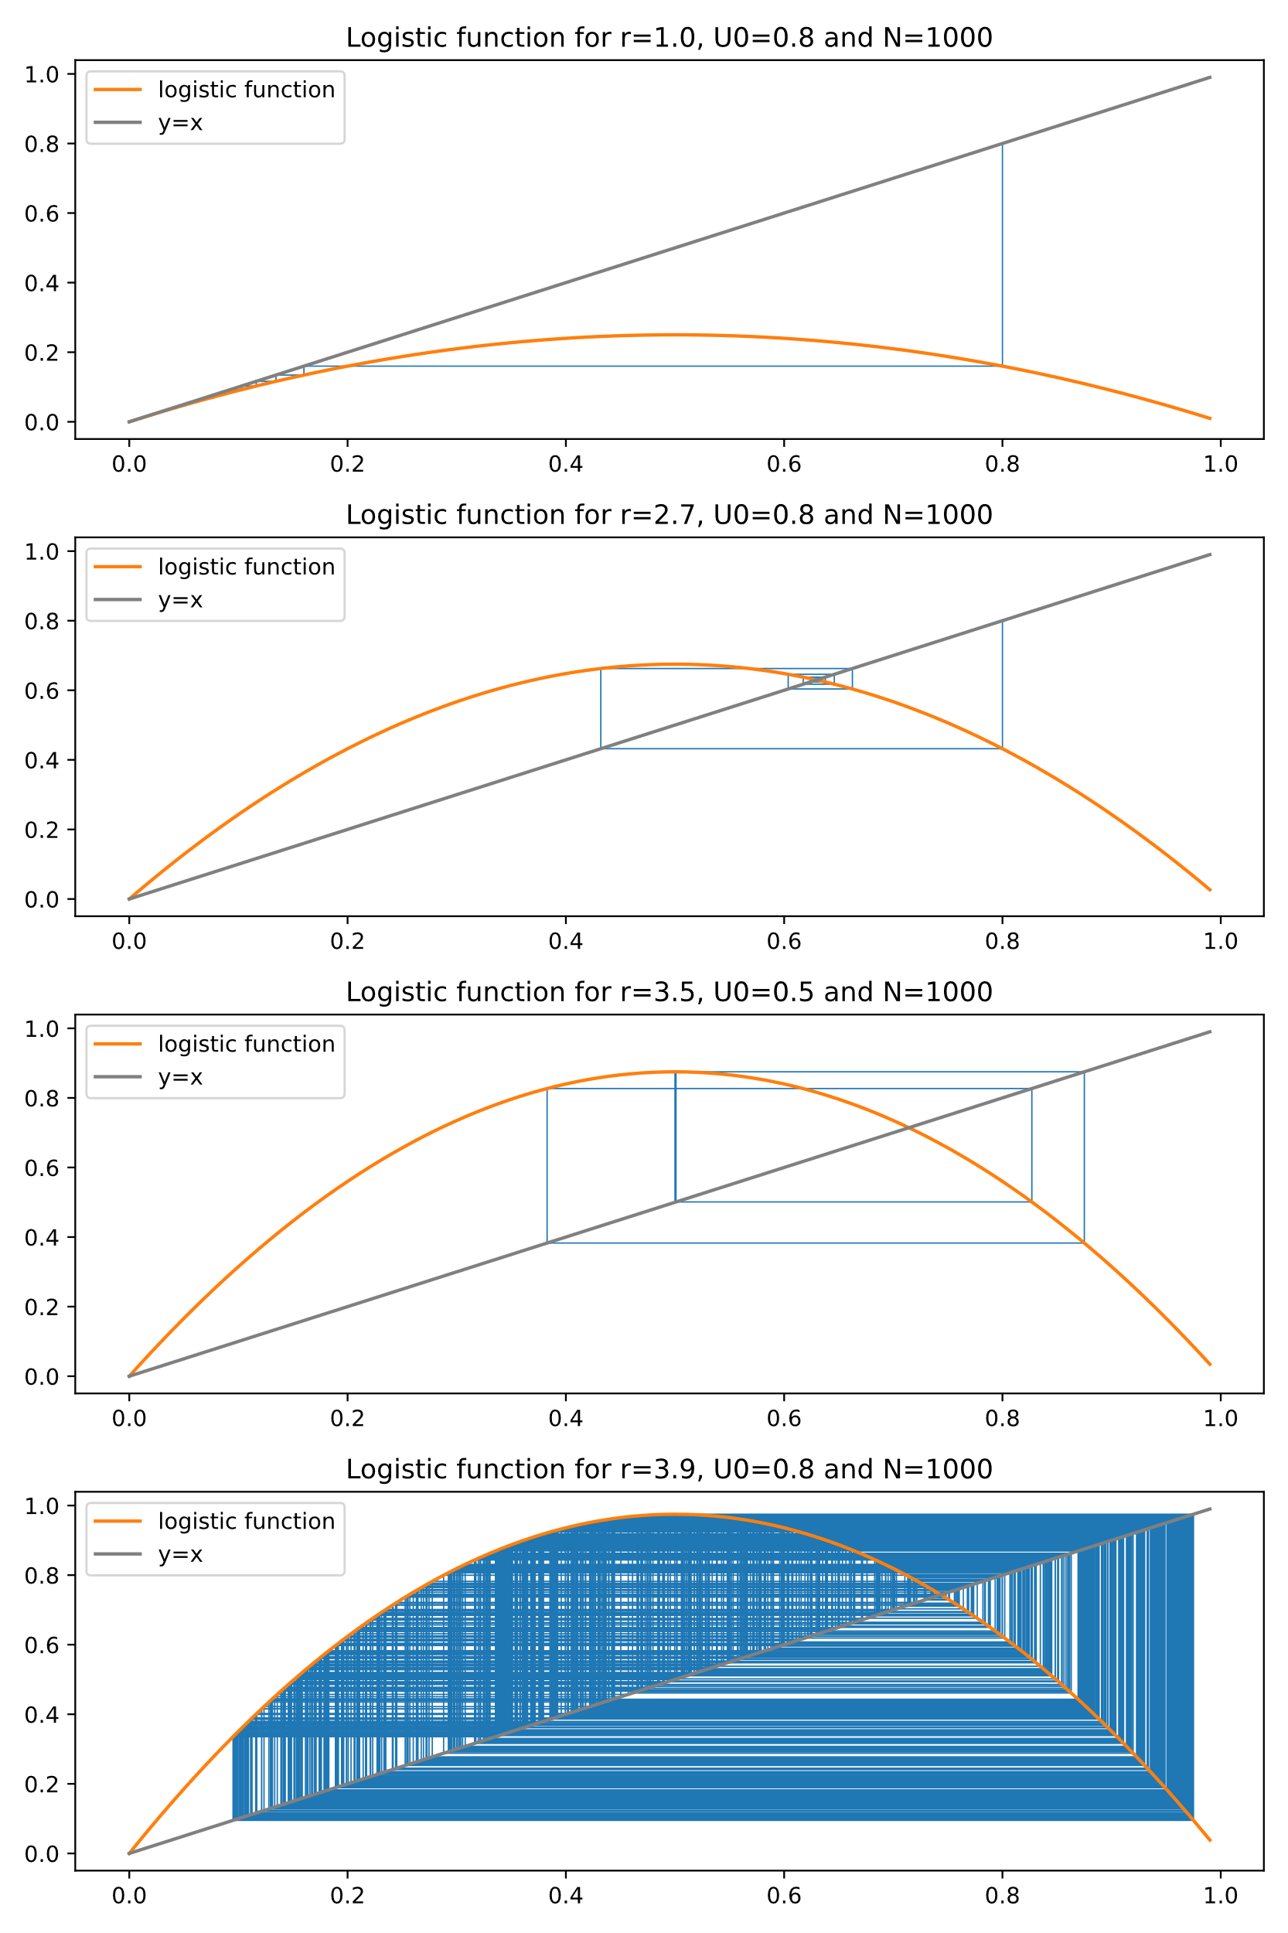

For the case where $r=1$ the function converges but if the value rises. Chaotic behavior can be observed. The values seem to rotate around the fixed point.

## The Feigenbaum diagram

To better view this chaotic behavior, we can trace what’s called a Feigenbaum diagram. This diagram shows for different values of r, the value taken by the Serie for a great number of iterations.

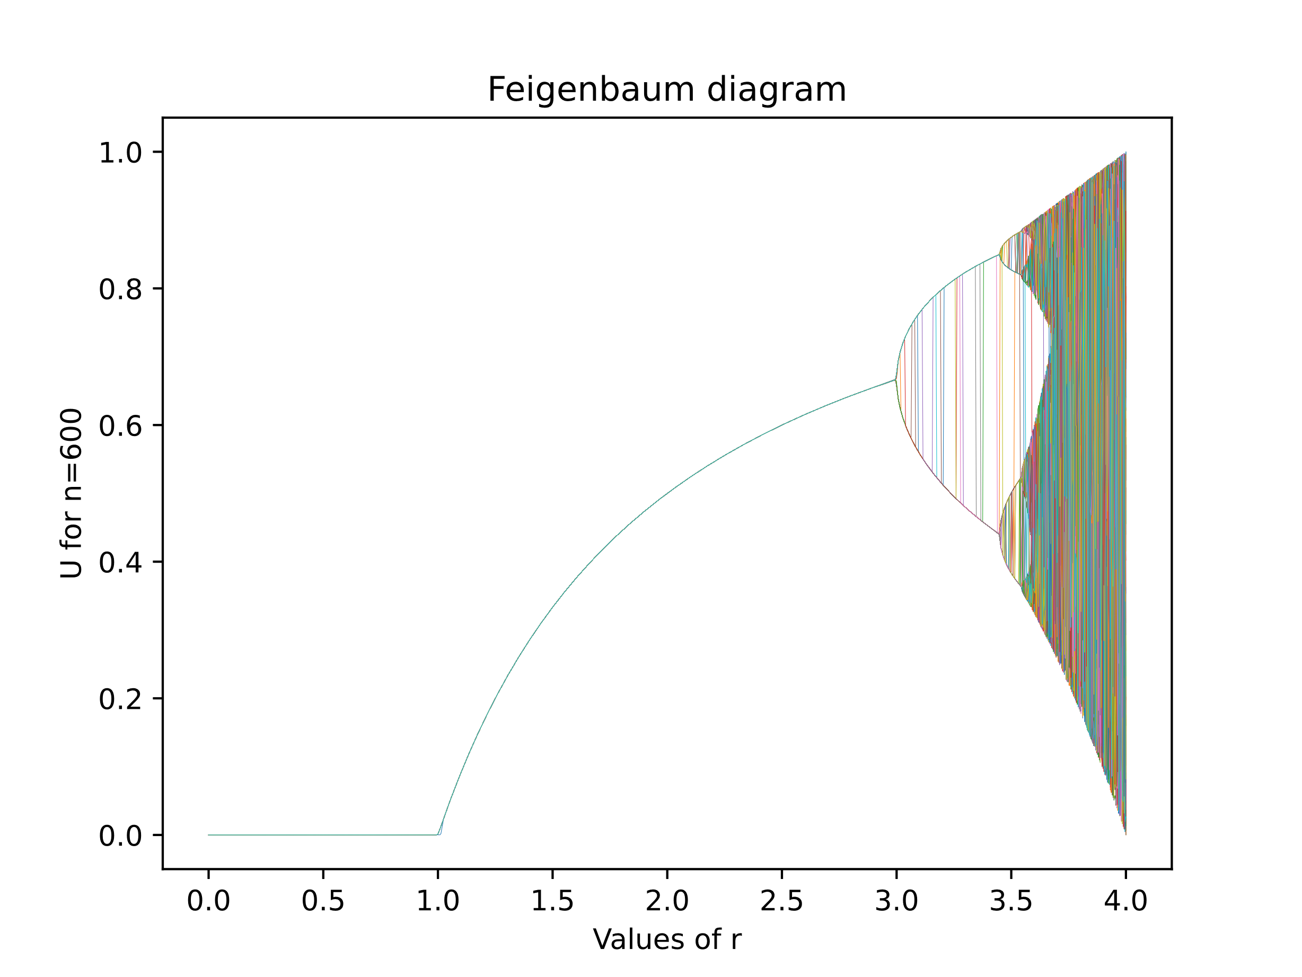

The figure above presents this diagram. Each color represents a different value for $u_{0}$. These values range from 0 to 1. We can perceive the different domains studied in class: fixed point, limit cycle and chaotic.

* A fixed point is a state where the system's behavior remains unchanged over time. It is a solution where the variables do not change or have zero rates of change. Fixed points can be stable (returning to equilibrium) or unstable (moving away from equilibrium). They provide insights into the system's behavior and stability.

On the Feigenbaum diagram we can see that the convergence seems independent of the initial value $u_{0}$ as long as a stays under 3.

We can note that for $r$ less than or equal to one, the fixed point is 0.

For $3>r>1$ this limit is given by $\lim_{n→∞}{u_{n}}=1-\frac{1}{r}$.It can be found by stating that $u_{n}$ and $u_{n+1}$ must converge to the same limit.

* The limit cycle is a repeating pattern or orbit to which the system's state converges over time. In the logistic map, limit cycles occur when the values repeatedly cycle through a finite set of values without converging to a fixed point or diverging to infinity. They represent stable, periodic behavior observed in various systems.
* At r ≈ 3.56995 (Wikipedia) chaos start appearing. With every initial condition, we no longer see oscillations of finite period. Depending on the initial value it’s almost impossible to describe to which value the series will converge. It’s observable by the fact that now every color on the graph seems to have taken a very specific pattern that does not resemble any of the other ones.

It also shows the sensitivity to the initial conditions because even if the 2 initial values are very close, they can take very different paths. As show in the following diagram:

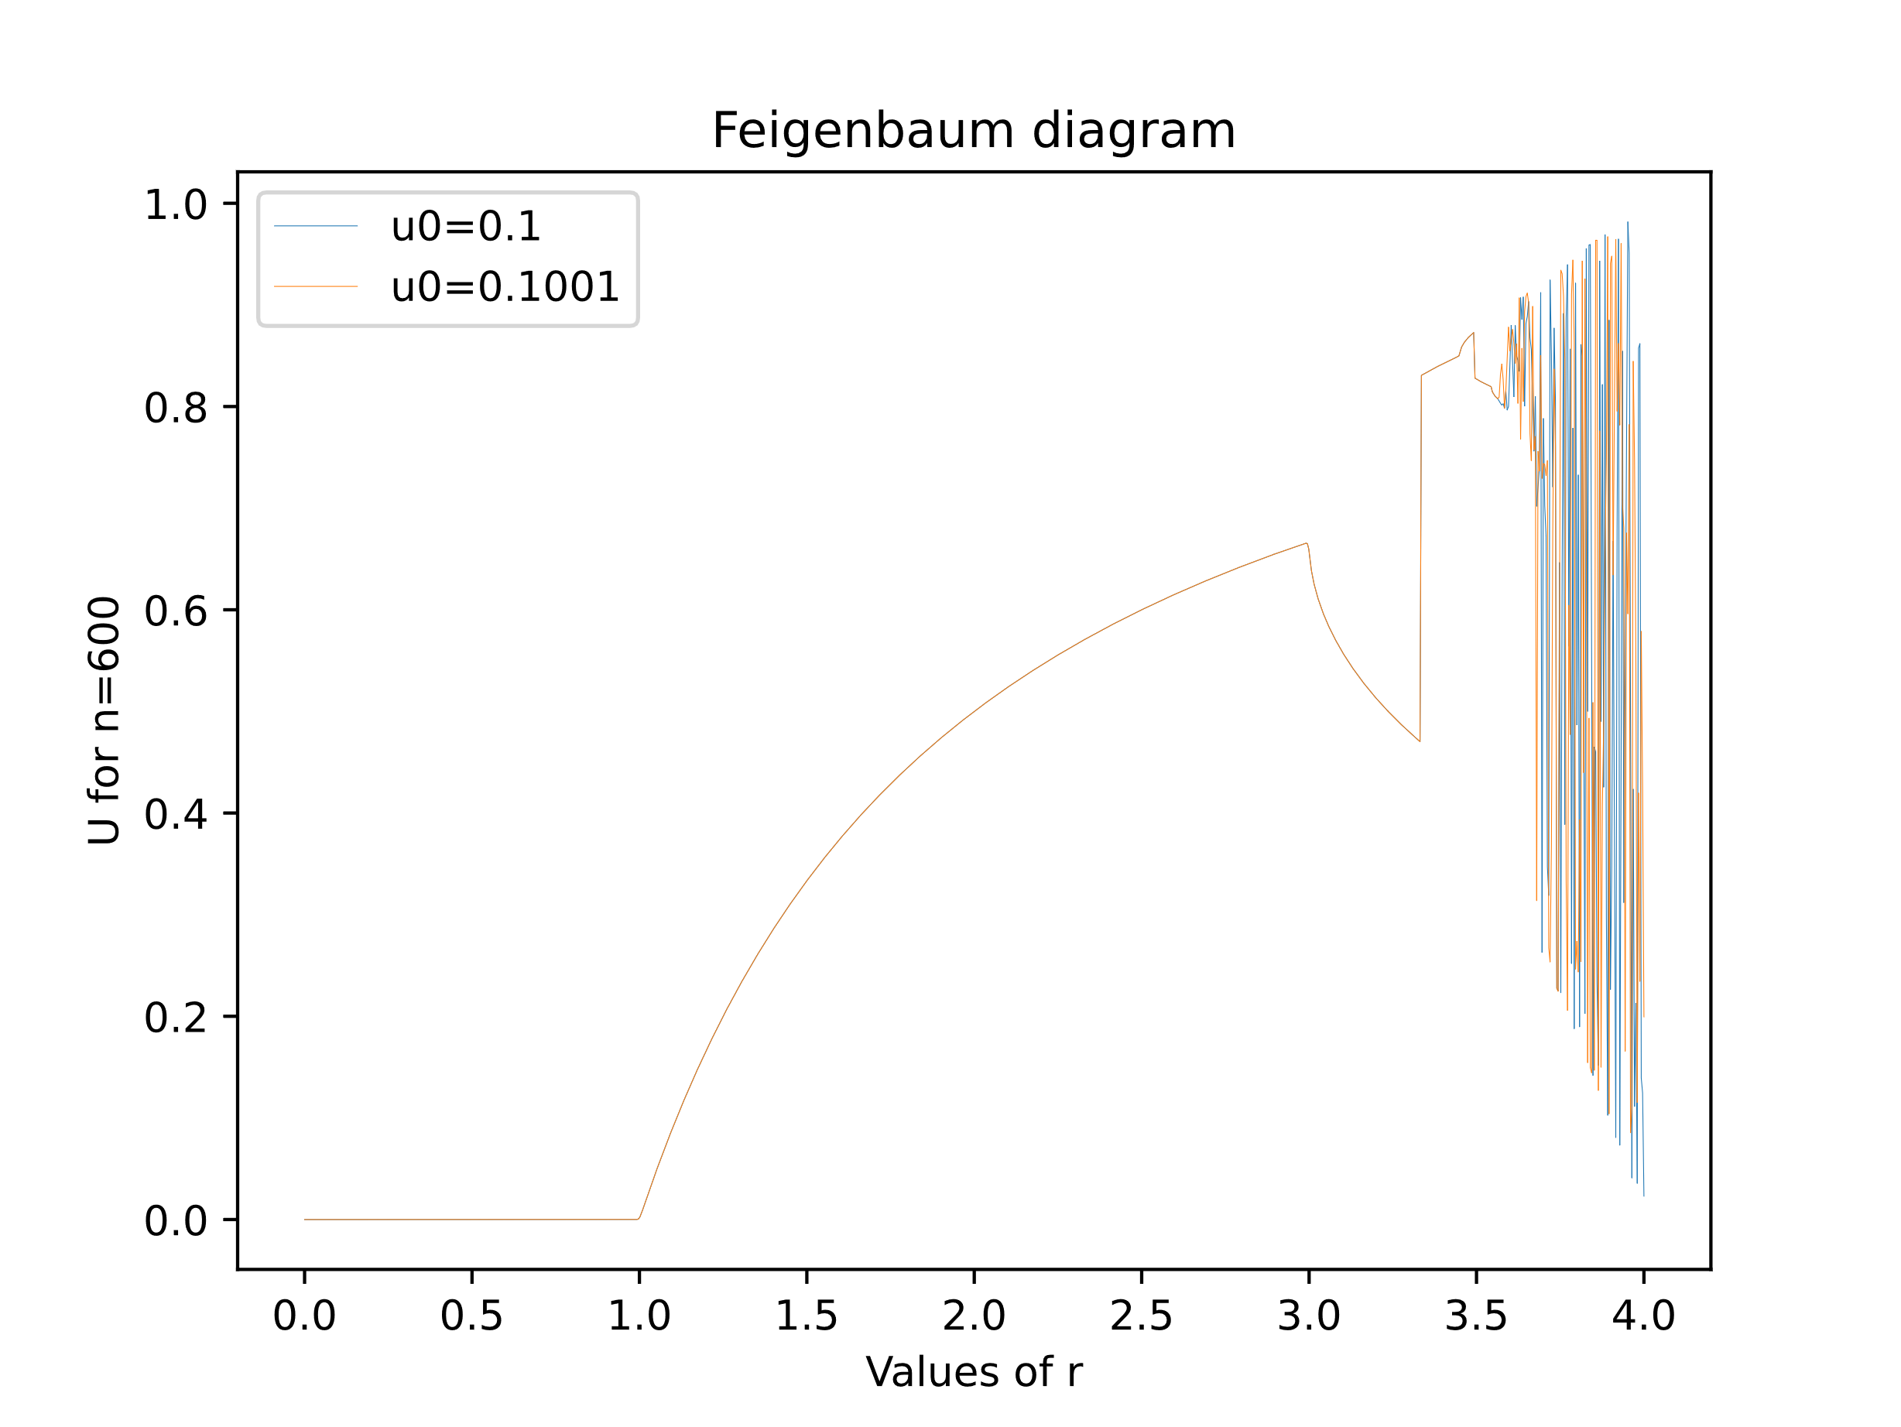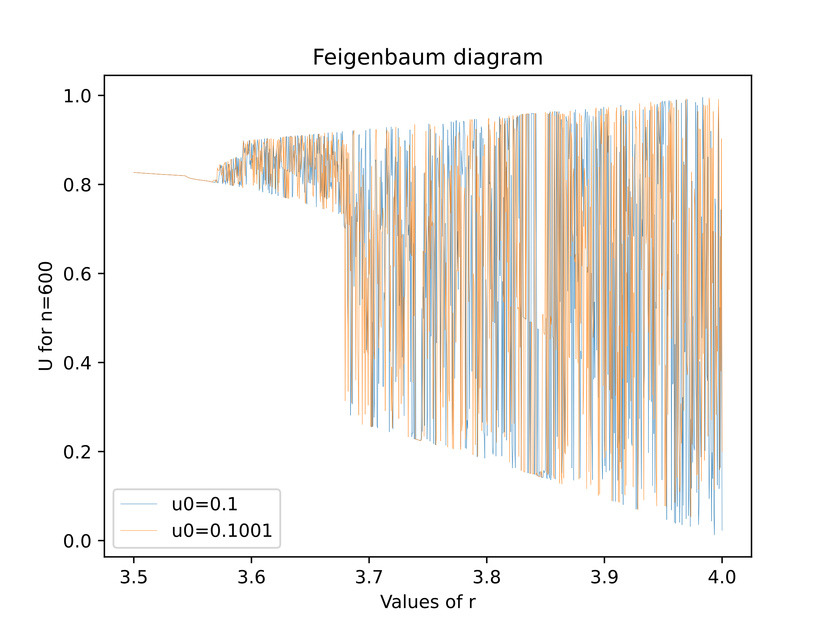

# Study of a continuous dynamic system

# Introduction of the system

For this part, we study the Lorenz system described as follows:

$$\left\{\begin{matrix}\frac{dx}{dt}=σ(y-x) \\ \frac{dy}{dt}=x\left(ρ-z\right)-y \\ \frac{dz}{dt}=xy- βz\end{matrix}\right.$$

To integrate these equations, I used the Runge-Kutta method defined by:

$$If: \frac{dx}{dt}=f\left(t,y\right), y\left(t_{0}\right)=y_{0} \\ Then: y_{n+1}= y_{n}+\frac{h}{6}\left(k_{1}+2k_{2}+2k_{3}+k_{4}\right) \\ With: \left\{\begin{aligned}\begin{matrix}k_{1}=f(t_{n}, { y}_{n}) \\ k_{2}=f(t_{n}+\frac{h}{2}, { y}_{n}+h\frac{k_{1}}{2})\end{matrix} \\ \begin{matrix}k_{3}=f(t_{n}+\frac{h}{2}, { y}_{n}+h\frac{k_{2}}{2}) \\ k_{4}=f(t_{n}+h, { y}_{n}+hk_{3})\end{matrix}\end{aligned}\right.$$

We then get this popular butterfly shape:

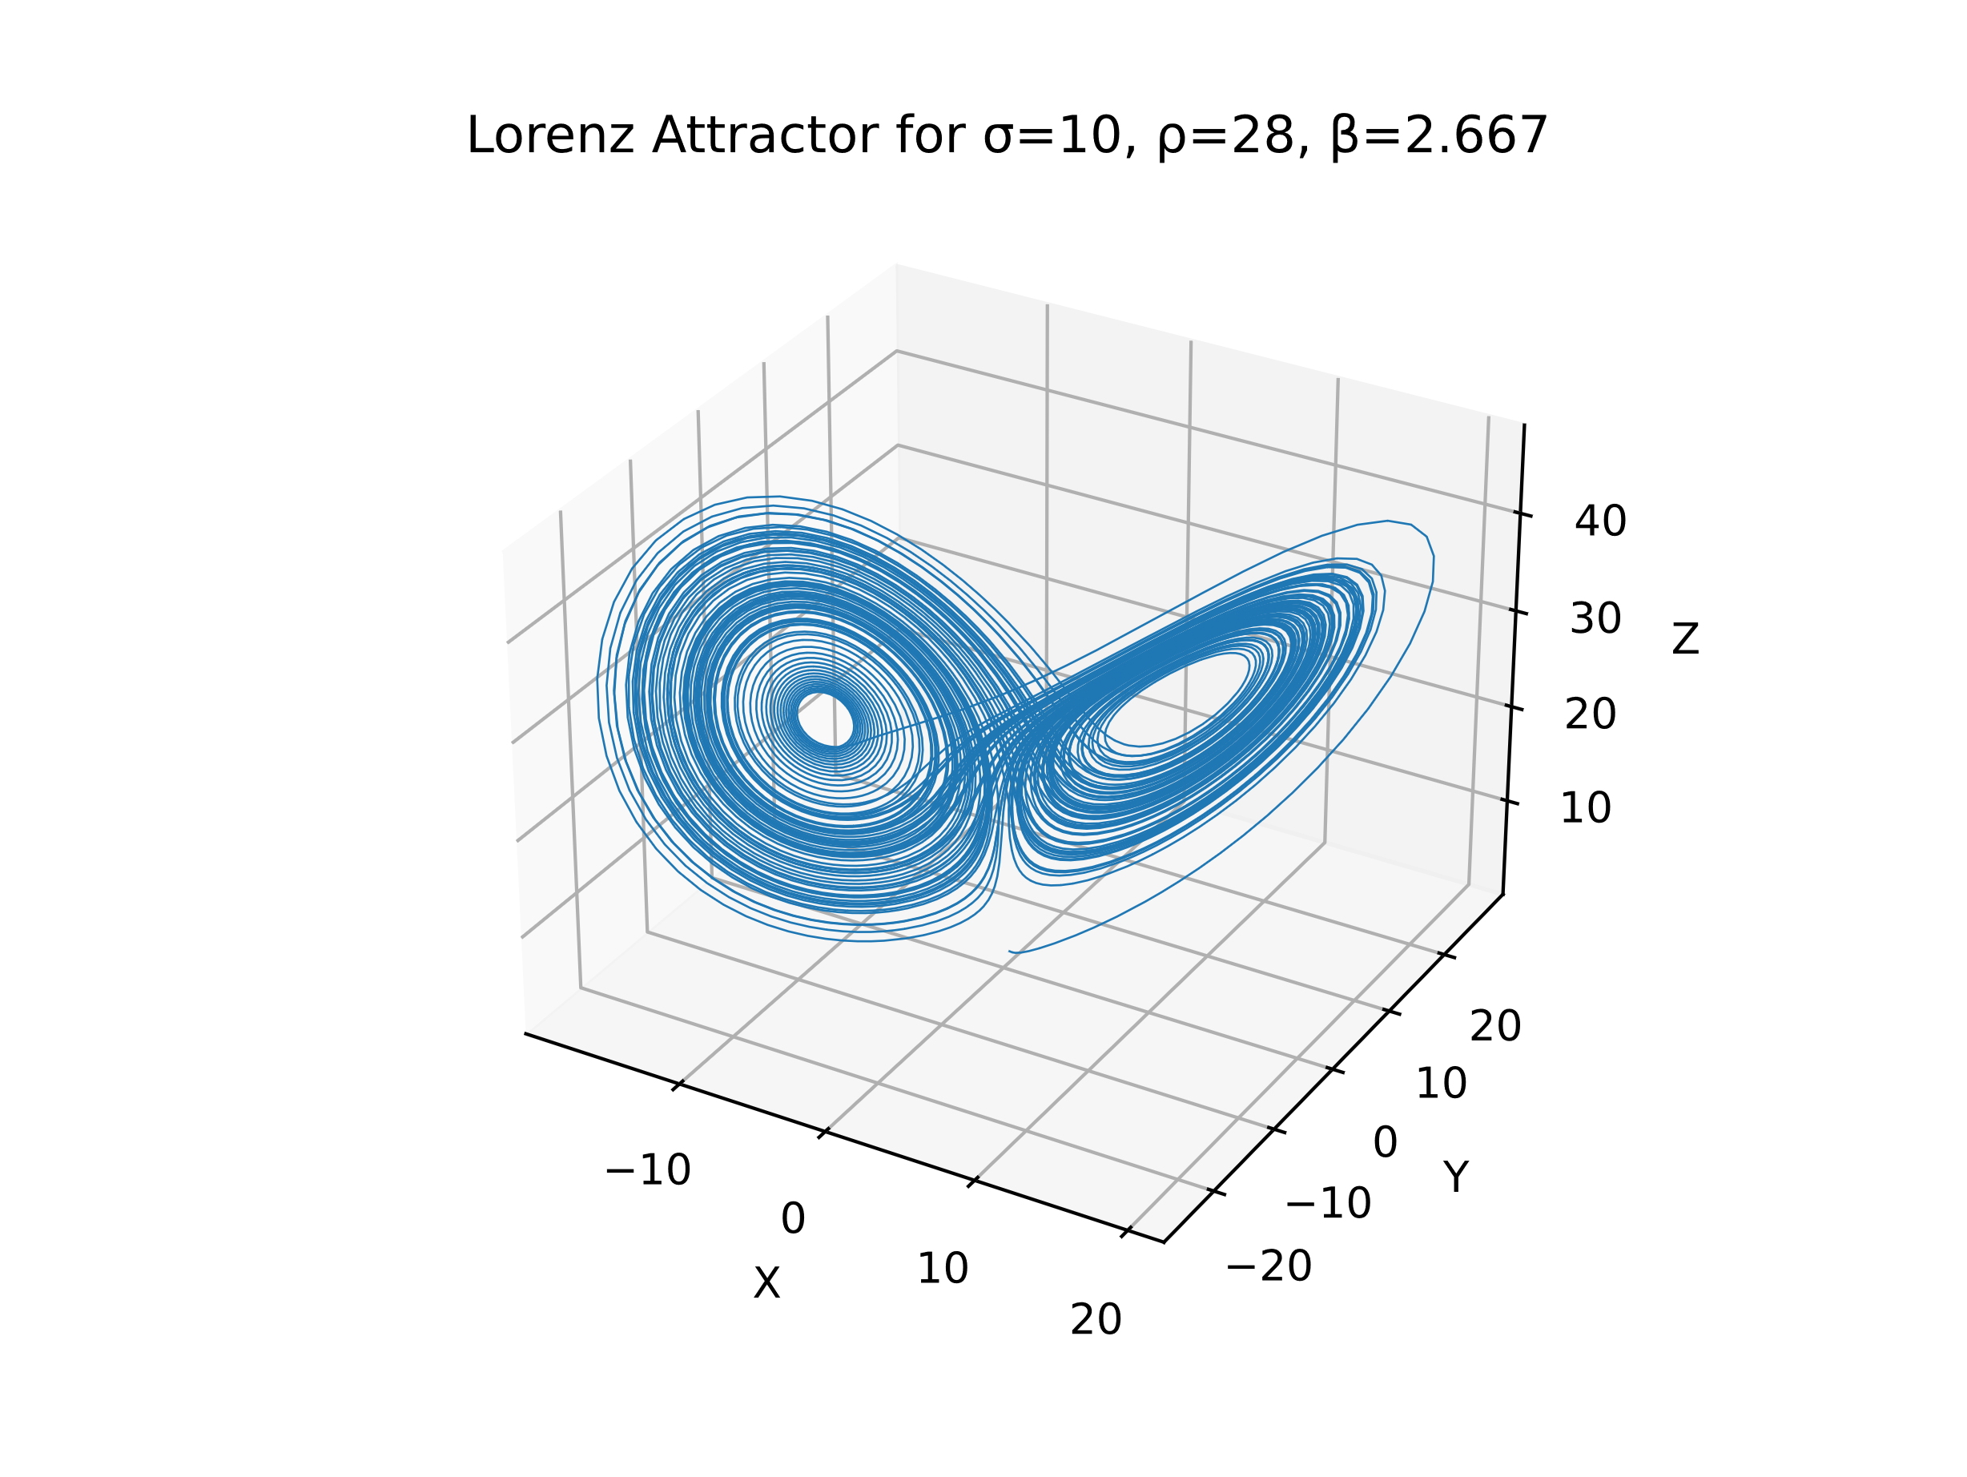

## Convergence over time

To have an idea of the trajectory over time, we can use color gradient. As time goes by, the color should turn from yellow to purple.

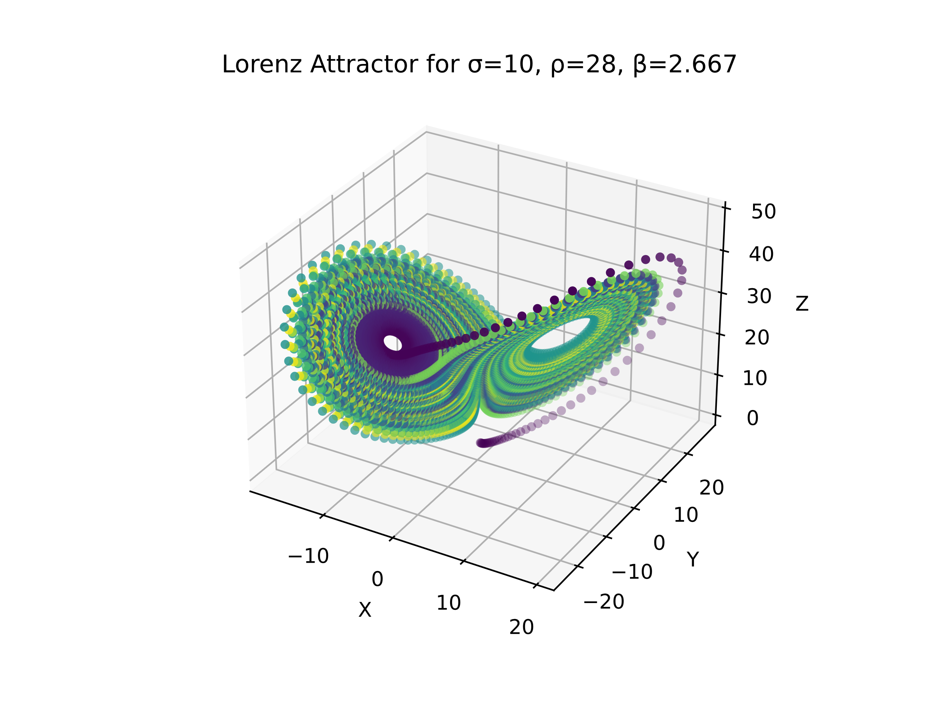

For these parameters the system seems to be attracted towards a center but in fact some purple points are in the exterior of the shape meaning that it never really seems to converge, and it just goes round and round between the points of attraction.

## Sensitivity to the initial conditions

If we also look at the initial conditions for the system, we can see that a slight change in the values can induce a drastic change in the trajectory followed. This demonstrates once again the sensitivity to the initial conditions of this kind of system.

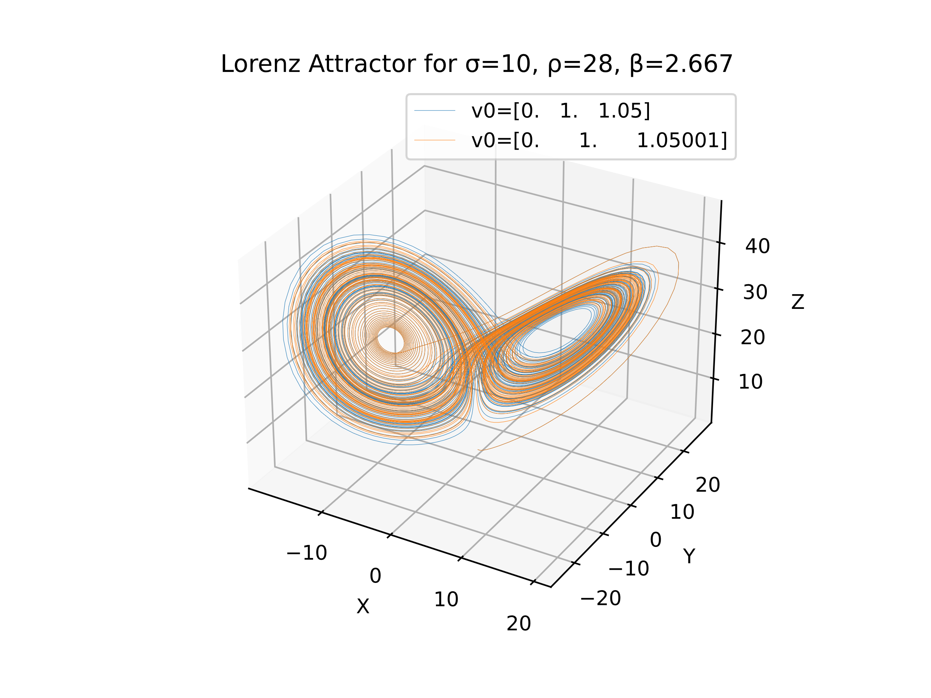

In this graph the values for v0 have a slight offset on the z coordinates but their trajectories happen to be very different.

## Fixed points

By examining the differential equation, fixed points must satisfy x = y, x(r − 1 − z) = 0, and bz = x 2 . In other words, we can just look at the behavior in the x–z plot, projected from the plane y = x. There are up to three fixed points: When x = 0, we also have y = z = 0, so the origin is a fixed point. Otherwise, assume that z = r − 1. For another fixed point, we need bz = x 2 , so r > 1. Then, we have two other fixed points, at x = y = ± √ bz and z = r − 1. So when r > 1, our fixed points are (0, 0, 0),( √ bz, √ bz, r − 1), and (− √ bz, − √ bz, r − 1).

If we want to find the fixed point of the system, we know that at these points, the system stop moving which implies that the derivatives is null:

$$\left\{\begin{matrix}\frac{dx}{dt}=0=σ(y-x) \\ \frac{dy}{dt}=0=x\left(ρ-z\right)-y \\ \frac{dz}{dt}=0=xy- βz\end{matrix}\right.$$ Which translates to:

$$\left\{\begin{matrix}y=x, (σ≠0) \\ y=x\left(ρ-z\right) \\ xy= βz\end{matrix}\right.⇒\left\{\begin{matrix}y=x \\ x=x\left(ρ-z\right) \\ x^{2}= βz\end{matrix}\right.⇒\left\{\begin{aligned}if x=0\left\{\begin{matrix}x=y=0 \\ 0=0 \\ 0= βz\end{matrix}\right.⇒\left\{\begin{matrix}x=0 \\ y=0 \\ z= 0\end{matrix}\right. \\ if x≠0\left\{\begin{matrix}y=x \\ 1=\left(ρ-z\right) \\ x^{2}= βz\end{matrix}\right.⇒\left\{\begin{matrix}x=±\sqrt{β (ρ-1)} \\ y=±\sqrt{β (ρ-1)} \\ z= ρ-1\end{matrix}\right.\end{aligned}\right.$$

So, the 3 fixed point of the system are the followings:

$$\left(0, 0, 0\right), \left(\sqrt{β \left(ρ-1\right)},\sqrt{β \left(ρ-1\right)},ρ-1 \right)and \left(-\sqrt{β \left(ρ-1\right)},-\sqrt{β \left(ρ-1\right)},ρ-1 \right)$$

If we add them to the previous we understand to which points the system is attracted to:

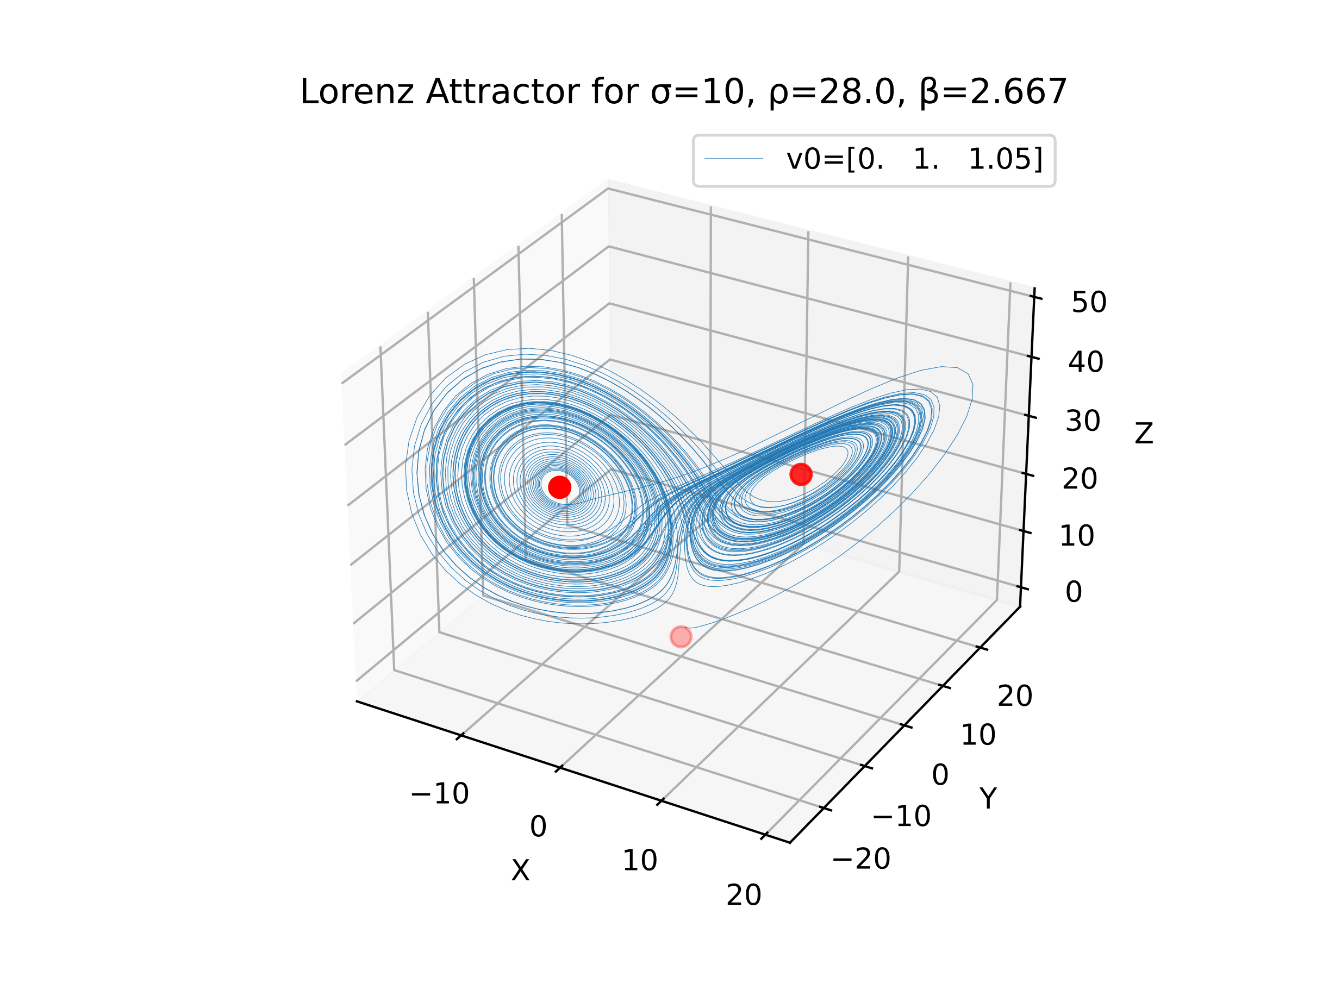

# Convergence cases

Until now we’ve studied the system under it’s chaotic aspect but it is possible to obtain the convergence of the system by altering the values of the parameters. One parameter usually considered for that is the parameter $ρ$.

If we take different values, we get the following results (please pay attention to the axes):

